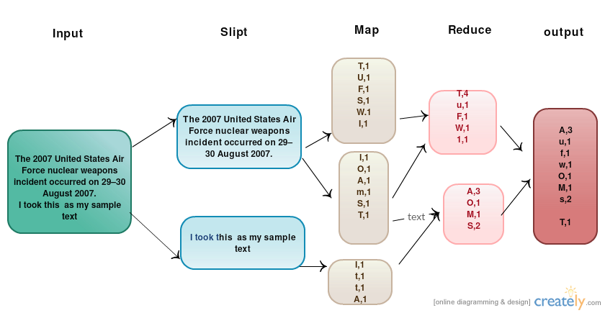

Input: taken the sample text

Output: Gives the count of how many word start with a Letter in a text file.